**Lecture # 16:**

**Objective:**

* Database Connectivity (DISCONNECTED)

o Record Selection

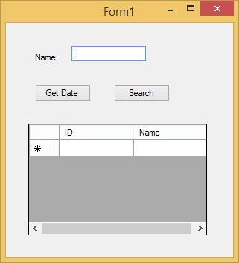View Data From Database (simple)

Presentation Layer

using System;

using System.Collections.Generic; using System.ComponentModel; using System.Data;

using System.Data.SqlClient; using System.Drawing;

using System.Linq; using System.Text;

using System.Threading.Tasks; using System.Windows.Forms;

namespace DisconnectedDB

{

public partial class Form1 : Form

{

public Form1()

{

InitializeComponent();

}

DataSet ds = new DataSet();

private void button1_Click(object sender, EventArgs e)

{

string strcon = @"Integrated Security=SSPI;Persist Security

Info=False;Initial Catalog=student;Data Source=ATECH\SQLEXPRESS"; SqlConnection sqlcon = new SqlConnection(strcon); sqlcon.Open();

string query = "select * from stdinfo"; SqlCommand sqlcmd = new SqlCommand(query, sqlcon); SqlDataAdapter sda = new SqlDataAdapter(sqlcmd); sda.Fill(ds);

}

private void button2_Click(object sender, EventArgs e)

{

DataRow[] dr = ds.Tables[0].Select("Name like '*" + textBox1.Text + "*'"); foreach (DataRow r in dr)

{

dataGridView1.Rows.Add(r[0].ToString(), r[1].ToString());

}

}

}

}